<https://www.youtube.com/watch?v=8aGhZQkoFbQ&t=389s&ab_channel=JSConf>

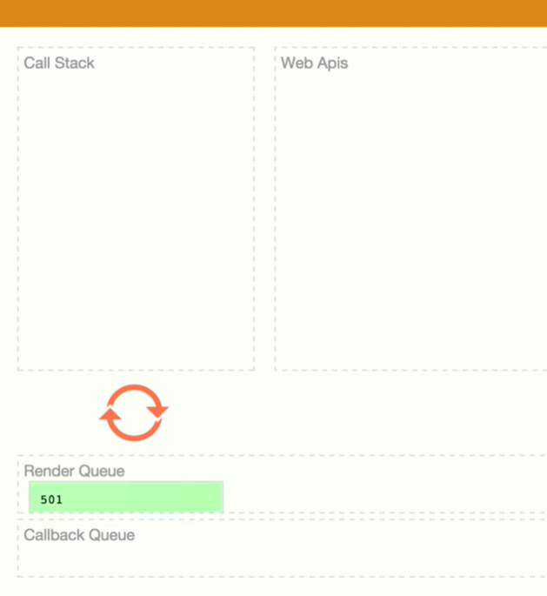

The event loop job is to look at the stack and look at the task queue. If the stack is empty, it takes the first thing on the queue and pushed it on to the stack.

<https://www.youtube.com/watch?v=BtOrr7oTH_8&ab_channel=ZacGordon>

